

Lab Report

**Digital Logic Design Lab**

**Submitted by:**

Name: Md Abdul Ohab Sarker

ID: 201900000061

**Submitted to:**

**Mohammad Ashraful hoque**

**Lecturer**

**Dept. of CSE**

**Southeast University**

**DHCP**

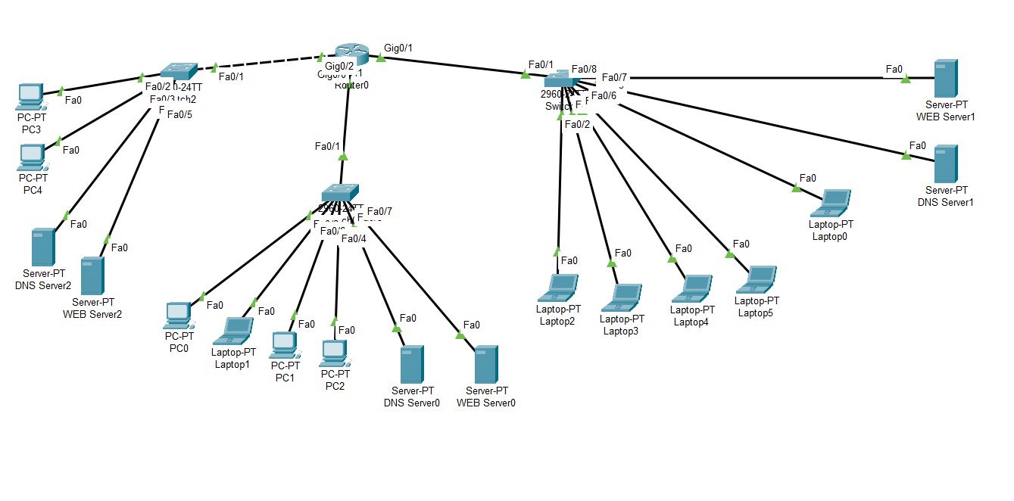

**Configuration:**

Router>en

Router#config t

Switch 0:

Router(config)#ip dhcp excluded-address 192.168.1.1 192.168.1.10

Router(config-if)#ip dhcp pool DHCP_Switch0

Router(dhcp-config)#network 192.168.1.0 255.255.255.192

Router(dhcp-config)#default-router 192.168.1.1

Router(dhcp-config)#dns-server 192.168.1.62

Router(dhcp-config)#int gig0/0

Router(config-if)#ip address 192.168.1.1 255.255.255.192

Router(config-if)#no shut

Switch1:

Router(config)#ip dhcp pool DHCP_Switch1

Router(dhcp-config)#network 192.168.1.64 255.255.255.192

Router(dhcp-config)#default-router 192.168.1.65

Router(dhcp-config)#dns-server 192.168.1.125

Router(dhcp-config)#int gig0/1

Router(config-if)#ip address 192.168.1.65 255.255.255.192

Router(config-if)#no shut

Switch 2:

Router(config)#ip dhcp pool DHCP_Switch3

Router(dhcp-config)#network 192.168.1.128 255.255.255.192

Router(dhcp-config)#default-router 192.168.1.129

Router(dhcp-config)#dns-server 192.168.1.189

Router(dhcp-config)#int gig0/2

Router(config-if)#ip address 192.168.1.129 255.255.255.192

Router(config-if)#no shut

#Switch1

#with DNS Server

config: 192.168.1.125

ip_config static:

IP Address: 192.168.1.125

Subnet MaeskL: 255.255.255.0

Default Geteway: 192.168.1.65

DNS Server: 192.168.1.125

service -> DNS -> Address : 192.168.1.124

service -> DNS -> Name : http://www.ohab.com

WEB Server:

IP Address: 192.168.1.124

Subnet MaeskL: 255.255.255.0

Default Geteway: 192.168.1.65

DNS Server: 192.168.1.125

**DHCP and HTTP Server**

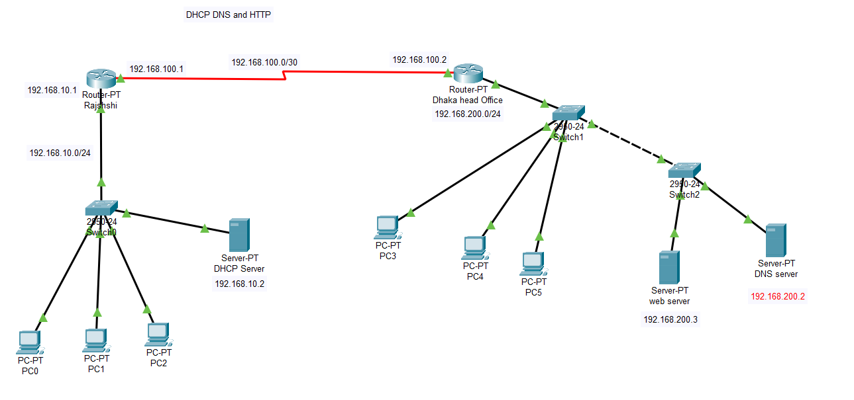

1. Router>en

2. Router#config t

3. Router(config)#hostname RAJSHAHI

4. RAJSHAHI(config)#int fa0/0

5. RAJSHAHI(config-if)#ip add 192.168.10.1 255.255.255.0

6. RAJSHAHI(config-if)#no shut

7.

8. RAJSHAHI(config-if)#

9. %LINK-5-CHANGED: Interface FastEthernet0/0, changed state to up

10.

11. %LINEPROTO-5-UPDOWN: Line protocol on Interface FastEthernet0/0, changed state to up

12.

13. RAJSHAHI(config-if)#int s2/0

14. RAJSHAHI(config-if)#ip add 192.168.100.1 255.255.255.252

17. RAJSHAHI(config-if)#clock rate 64000

18. RAJSHAHI(config-if)#no shut

19.

20. %LINK-5-CHANGED: Interface Serial2/0, changed state to down

21. RAJSHAHI(config-if)#no shut

**Routing Dhaka head office:**

1. Router>en

2. Router#config t

3. Router(config)#hostname DHAKA

4. DHAKA (config)#int fa0/0

5. DHAKA (config-if)#ip add 192.168.200.1 255.255.255.0

6. DHAKA (config-if)#no shut

7.

8. DHAKA (config-if)#

9. %LINK-5-CHANGED: Interface FastEthernet0/0, changed state to up

10.

11. %LINEPROTO-5-UPDOWN: Line protocol on Interface FastEthernet0/0, changed state to up

12.

13. DHAKA (config-if)#int s2/0

14. DHAKA (config-if)#ip add 192.168.100.2 255.255.255.252

17. DHAKA (config-if)#clock rate 64000

18. DHAKA (config-if)#no shut

19.

20. %LINK-5-CHANGED: Interface Serial2/0, changed state to down

21. DHAKA (config-if)#no shut

**DNS and WEB Server**

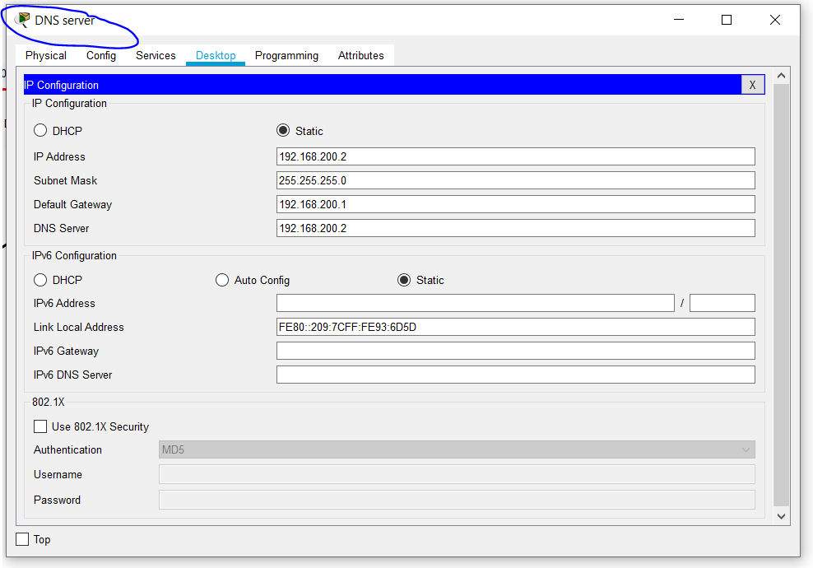

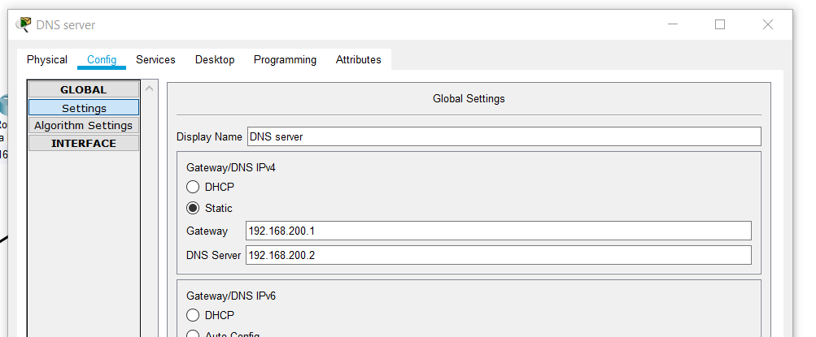

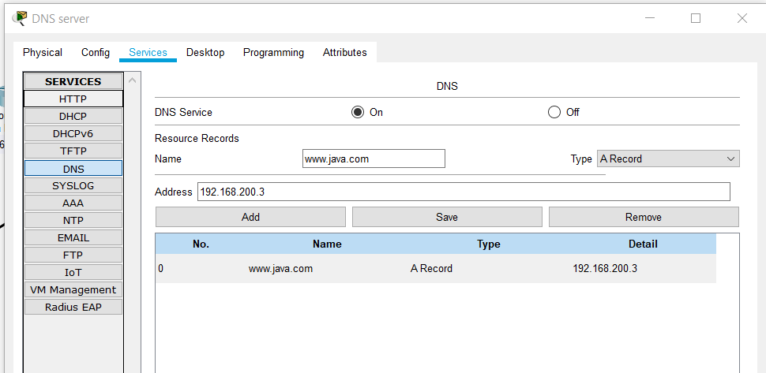

**Web server:**

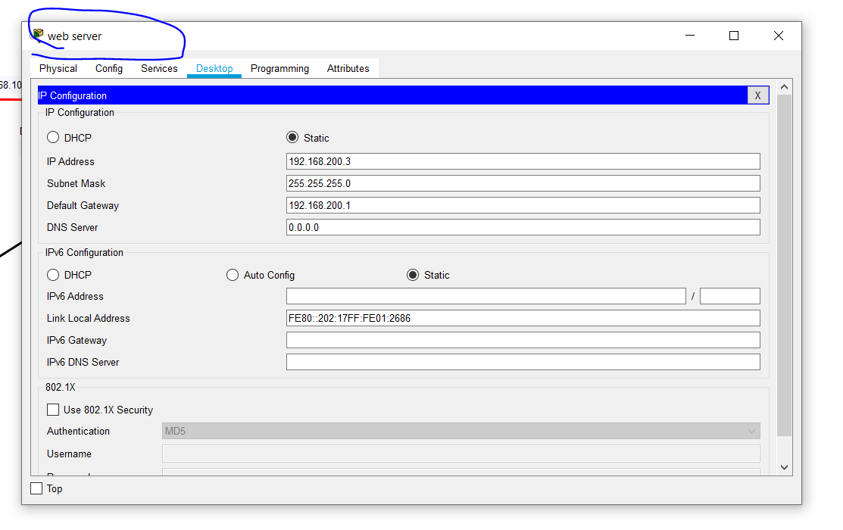

**Static routing:**

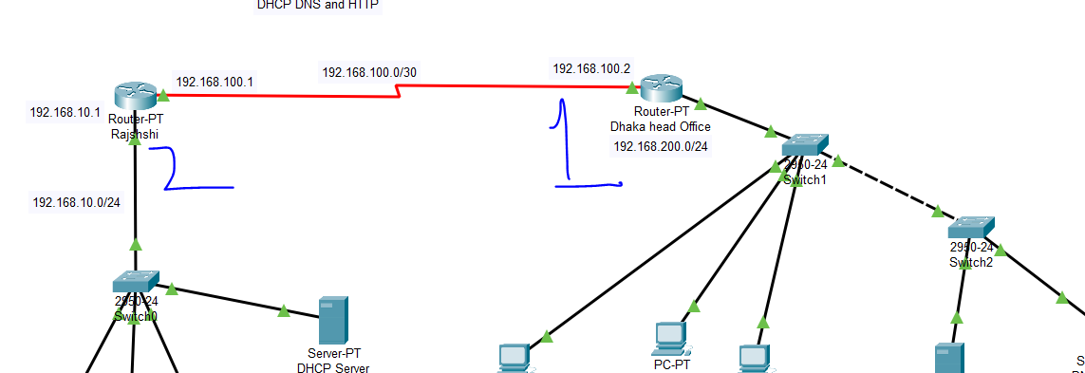

**1:**

1. DHAKA>

2. DHAKA>en

9. DHAKA#config t

10. Enter configuration commands, one per line. End with CNTL/Z.

11. DHAKA(config)#ip route 192.168.10.0 255.255.255.0 192.168.100.1

12. DHAKA(config)#^Z

13. DHAKA#

14. %SYS-5-CONFIG_I: Configured from console by console

15. show ip route

16. Codes: C - connected, S - static, I - IGRP, R - RIP, M - mobile, B - BGP

17. D - EIGRP, EX - EIGRP external, O - OSPF, IA - OSPF inter area

18. N1 - OSPF NSSA external type 1, N2 - OSPF NSSA external type 2

19. E1 - OSPF external type 1, E2 - OSPF external type 2, E - EGP

20. i - IS-IS, L1 - IS-IS level-1, L2 - IS-IS level-2, ia - IS-IS inter area

21. * - candidate default, U - per-user static route, o - ODR

22. P - periodic downloaded static route

23.

24. Gateway of last resort is not set

25.

26. S 192.168.10.0/24 [1/0] via 192.168.100.1

27. 192.168.100.0/30 is subnetted, 1 subnets

28. C 192.168.100.0 is directly connected, Serial2/0

29. C 192.168.200.0/24 is directly connected, FastEthernet0/0

30.

31. DHAKA#

2:

9. RAJSHAHI>en

10. RAJSHAHI#config t

11. Enter configuration commands, one per line. End with CNTL/Z.

12. RAJSHAHI(config)#ip route 192.168.200.0 255.255.255.0 192.168.100.2

23. RAJSHAHI#sh ip route

34. C 192.168.10.0/24 is directly connected, FastEthernet0/0

35. 192.168.100.0/30 is subnetted, 1 subnets

36. C 192.168.100.0 is directly connected, Serial2/0

37. S 192.168.200.0/24 [1/0] via 192.168.100.2

38.

39. RAJSHAHI#

**VLAN**

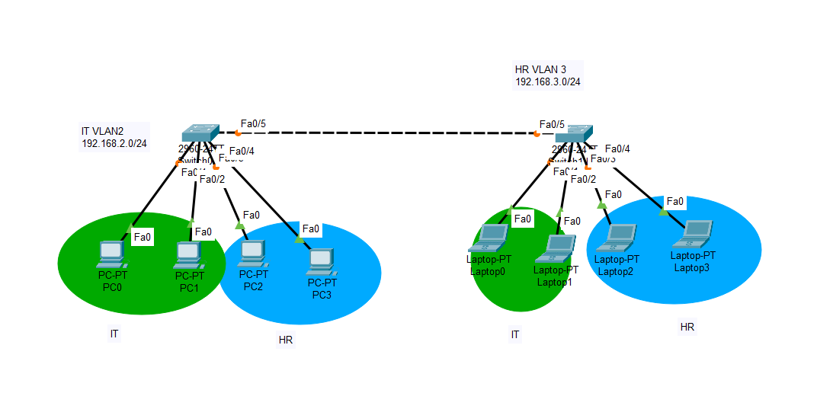

Vlan For It departmanet:

Switch>en

Switch#

Switch#sh vlan brief

VLAN Name Status Ports

---- -------------------------------- --------- -------------------------------

1 default active Fa0/1, Fa0/2, Fa0/3, Fa0/4

Fa0/5, Fa0/6, Fa0/7, Fa0/8

Fa0/9, Fa0/10, Fa0/11, Fa0/12

Fa0/13, Fa0/14, Fa0/15, Fa0/16

Fa0/17, Fa0/18, Fa0/19, Fa0/20

Fa0/21, Fa0/22, Fa0/23, Fa0/24

Gig0/1, Gig0/2

1002 fddi-default active

1003 token-ring-default active

1004 fddinet-default active

1005 trnet-default active

Switch#config t

Switch(config)#vlan 2

Switch(config-vlan)#name IT

Switch(config-vlan)#vlan 3

Switch(config-vlan)#name HR

Switch#sh vlan brief

VLAN Name Status Ports

---- -------------------------------- --------- -------------------------------

1 default active Fa0/1, Fa0/2, Fa0/3, Fa0/4

Fa0/5, Fa0/6, Fa0/7, Fa0/8

Fa0/9, Fa0/10, Fa0/11, Fa0/12

Fa0/13, Fa0/14, Fa0/15, Fa0/16

Fa0/17, Fa0/18, Fa0/19, Fa0/20

Fa0/21, Fa0/22, Fa0/23, Fa0/24

Gig0/1, Gig0/2

2 it active

3 HR active

Switch(config)#int range fa0/1-2

Switch(config-if-range)#switchport access vlan 2

Switch(config)#int range fa0/3-4

Switch(config-if-range)#switchport access vlan 3

Switch#show vlan brief

VLAN Name Status Ports

---- -------------------------------- --------- -------------------------------

1 default active Fa0/5, Fa0/6, Fa0/7, Fa0/8

Fa0/9, Fa0/10, Fa0/11, Fa0/12

Fa0/13, Fa0/14, Fa0/15, Fa0/16

Fa0/17, Fa0/18, Fa0/19, Fa0/20

Fa0/21, Fa0/22, Fa0/23, Fa0/24

Gig0/1, Gig0/2

2 it active Fa0/1, Fa0/2

3 HR active Fa0/3, Fa0/4

**Administrative Mode: dynamic mode to turn into static access

Switch#config t

Switch(config)#int range fa 0/1-4

Switch(config-if-range)#switchport mode access

Switch#show interfaces switchport

Name: Fa0/1

Switchport: Enabled

Administrative Mode: static access**

Operational Mode: static access

**this stablish a Trunk ...

** inter switch connection with trank mode

Switch(config)#int fa 0/5

Switch(config-if)#switchport mode trunk

Switch#sh interfaces trunk

Port Mode Encapsulation Status Native vlan

Fa0/5 **on **802.1q trunking 1

**this another switch trunk mode on automaticly . . .

*** switch 2

==============

Switch>en

Switch(config)#vlan 2

Switch(config-vlan)#name IT

Switch(config-vlan)#vlan 3

Switch(config-vlan)#name HR

Switch(config-vlan)#int range fa0/1-2

Switch(config-if-range)#switchport access vlan 2

Switch(config-if-range)#int range fa0/3-4

Switch(config-if-range)#switchport access vlan 3

Switch(config-if-range)#^Z

Switch#sh vlan brief

VLAN Name Status Ports

---- -------------------------------- --------- -------------------------------

1 default active Fa0/6, Fa0/7, Fa0/8, Fa0/9

Fa0/10, Fa0/11, Fa0/12, Fa0/13

Fa0/14, Fa0/15, Fa0/16, Fa0/17

Fa0/18, Fa0/19, Fa0/20, Fa0/21

Fa0/22, Fa0/23, Fa0/24, Gig0/1

Gig0/2

2 IT active Fa0/1, Fa0/2

3 HR active Fa0/3, Fa0/4

Switch(config)#int range fa 0/1-4

Switch(config-if-range)#switchport mode access

Switch#show interfaces switchport

Name: Fa0/1

Switchport: Enabled

Administrative Mode: static access**

Operational Mode: static access

**Inter-Vlan**

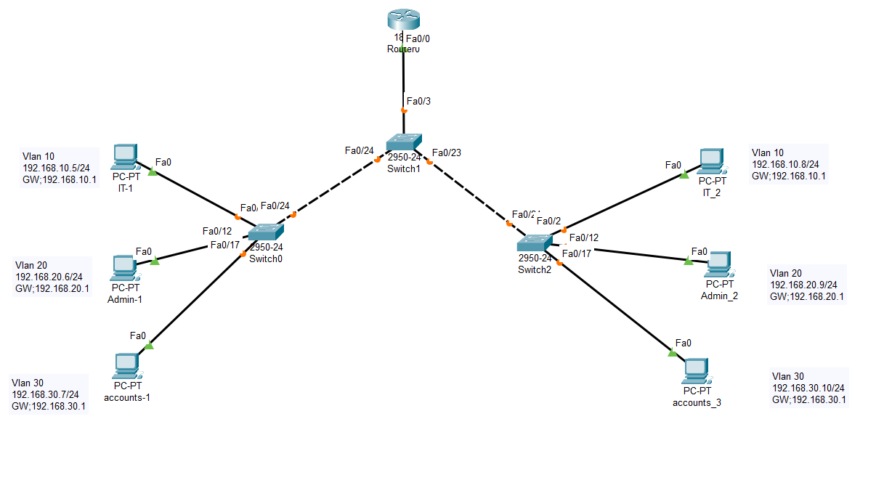

Create 3 vlan in every switch:

Switch0

Switch>en

Switch#config t

Switch(config)#vlan 10

Switch(config-vlan)#name IT

Switch(config)#vlan 20

Switch(config-vlan)#name ADMIN

Switch(config)#vlan 30

Switch(config-vlan)#name ACCOUNTS

Switch(config)#do wr

Building configuration...

[OK]

Switch#sh vlan brief

VLAN Name Status Ports

---- -------------------------------- --------- -------------------------------

1 default active Fa0/1, Fa0/2, Fa0/3, Fa0/4

Fa0/5, Fa0/6, Fa0/7, Fa0/8

10 IT active

20 ADMIN active

30 ACCOUNTS active

1002 fddi-default active

Switch(config)#int range fa0/1-10

Switch(config-if-range)#switchport mode access

Switch(config-if-range)#switchport access vlan 10

Switch(config-if-range)#no shut

Switch(config)#int range fa0/11-15

Switch(config-if-range)#switchport mode access

Switch(config-if-range)#switchport access vlan 20

Switch(config-if-range)#no shut

Switch(config-if-range)#int range fa0/16-20

Switch(config-if-range)#switchport mode access

Switch(config-if-range)#switchport access vlan 30

Switch(config-if-range)#no shut

Switch#sh vlan brief

VLAN Name Status Ports

---- -------------------------------- --------- -------------------------------

1 default active Fa0/21, Fa0/22, Fa0/23, Fa0/24

10 IT active Fa0/1, Fa0/2, Fa0/3, Fa0/4

Fa0/5, Fa0/6, Fa0/7, Fa0/8

Fa0/9, Fa0/10

20 ADMIN active Fa0/11, Fa0/12, Fa0/13, Fa0/14

Fa0/15

30 ACCOUNTS active Fa0/16, Fa0/17, Fa0/18, Fa0/19

Fa0/20

1002 fddi-default active

1003 token-ring-default active

Switch(config)#do wr

Building configuration...

[OK]

**Connect to another switch

Switch#sh interfaces trunk

Port Mode Encapsulation Status Native vlan

Fa0/24 **auto n-802.1q trunking 1

Switch(config)#int fa 0/24

Switch(config-if)#switchport mode trunk

Switch(config-if)#no shut

Switch(config-if)#exit

Switch#sh interfaces trunk

Port Mode Encapsulation Status Native vlan

Fa0/24 **on 802.1q trunking 1

*Switch 2

Switch>en

Switch#config t

Switch(config)#vlan 10

Switch(config-vlan)#name IT

Switch(config)#vlan 20

Switch(config-vlan)#name ADMIN

Switch(config)#vlan 30

Switch(config-vlan)#name ACCOUNTS

Switch(config)#do wr

Building configuration...

[OK]

Switch(config)#int range fa0/1-10

Switch(config-if-range)#switchport mode access

Switch(config-if-range)#switchport access vlan 10

Switch(config-if-range)#no shut

Switch(config-if-range)#exit

Switch(config)#int range fa0/11-15

Switch(config-if-range)#switchport mode access

Switch(config-if-range)#switchport access vlan 20

Switch(config-if-range)#no shut

Switch(config-if-range)#exit

Switch(config)#int range fa0/16-20

Switch(config-if-range)#switchport mode access

Switch(config-if-range)#switchport access vlan 30

Switch(config-if-range)#no shut

Switch(config-if-range)#exit

Switch#sh vlan brief

VLAN Name Status Ports

---- -------------------------------- --------- -------------------------------

1 default active Fa0/21, Fa0/22, Fa0/23, Fa0/24

10 IT active Fa0/1, Fa0/2, Fa0/3, Fa0/4

Fa0/5, Fa0/6, Fa0/7, Fa0/8

Fa0/9, Fa0/10

20 ADMIN active Fa0/11, Fa0/12, Fa0/13, Fa0/14

Fa0/15

30 ACCOUNTS active Fa0/16, Fa0/17, Fa0/18, Fa0/19

Fa0/20

Switch#sh interfaces trunk

Port Mode Encapsulation Status Native vlan

Fa0/24 **auto n-802.1q trunking 1

Switch(config)#int fa 0/24

Switch(config-if)#switchport mode trunk

Switch(config-if)#no shut

Switch(config-if)#exit

Switch(config)#do wr

Building configuration...

[OK]

Switch#sh interfaces trunk

Port Mode Encapsulation Status Native vlan

Fa0/24 **on 802.1q trunking 1

*Switch 1

Switch(config)#vlan 10

Switch(config-vlan)#name IT

Switch(config)#vlan 20

Switch(config-vlan)#name ADMIN

Switch(config)#vlan 30

Switch(config-vlan)#name ACCOUNTS

Switch#sh vlan brief

VLAN Name Status Ports

---- -------------------------------- --------- -------------------------------

1 default active Fa0/1, Fa0/2, Fa0/3, Fa0/4

Fa0/5, Fa0/6, Fa0/7, Fa0/8

Fa0/9, Fa0/10, Fa0/11, Fa0/12

10 IT active

20 ADMIN active

30 ACCOUNTS active

Switch(config)#int fa 0/24

Switch(config-if)#switchport mode trunk

Switch(config)#int fa0/3

Switch(config-if)#switchport mode trunk

Switch(config-if)#no shut

Switch(config-if)#exit

Switch(config)#int fa 0/23

Switch(config-if)#switchport mode trunk

**Router 0

Router>en

Router#config t

Router(config)#int fa 0/0

Router(config-if)#no shut

Router(config-if)#exit

Router(config)#interface fa0/0.10

Router(config-subif)#encapsulation dot1Q 10

Router(config-subif)#ip add 192.168.10.1 255.255.255.0

Router(config-subif)#exit

Router(config)#interface fa0/0.20

Router(config-subif)#encapsulation dot1Q 20

Router(config-subif)#ip add 192.168.20.1 255.255.255.0

Router(config-subif)#exit

Router(config)#interface fa0/0.30

Router(config-subif)#encapsulation dot1Q 30

Router(config-subif)#ip add 192.168.30.1 255.255.255.0

Router(config-subif)#no shut

Router(config-subif)#exit

Router#show running-config

interface FastEthernet0/0.10

encapsulation dot1Q 10

ip address 192.168.100.1 255.255.255.0

!

interface FastEthernet0/0.20

encapsulation dot1Q 20

ip address 192.168.20.1 255.255.255.0

!

interface FastEthernet0/0.30

encapsulation dot1Q 30

ip address 192.168.30.1 255.255.255.0

RIP

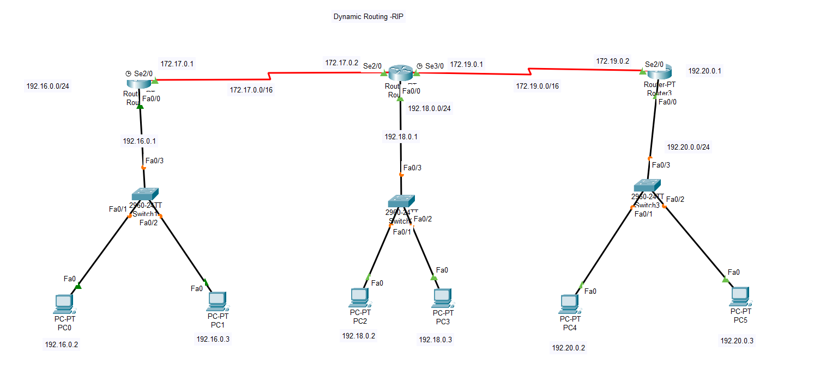

//first router R0

IP: 192.16.0.1

configure DHCP address

Router(config)#ip dhcp pool SEU1

Router(dhcp-config)# network 192.16.0.1 255.255.255.0

Router(dhcp-config)# default-router 192.16.0.1 //gW

Router(config-if)#int fa 0/0

Router(config-if)#ip add 192.16.0.1 255.255.255.0

Router(config-if)#no shut

Router(config-if)#exit

#interface Serial2/0

ip address 172.17.0.1 255.255.0.0

R-1(config)#router rip

R-1(config-router)#network 192.16.0.0

R-1(config-router)#network 172.17.0.0

//R2

Router(config)#ip dhcp pool SEU1

Router(dhcp-config)# network 192.18.0.1 255.255.255.0

Router(dhcp-config)# default-router 192.18.0.1 //gW

Router(config-if)#int fa 0/0

Router(config-if)#ip add 192.18.0.1 255.255.255.0

Router(config-if)#no shut

Router(config-if)#exit

#interface Serial2/0

ip address 172.17.0.1 255.255.0.0

#interface Serial2/0

ip address 172.17.0.2 255.255.0.0

router rip

network 172.17.0.0

network 172.18.0.0

network 192.19.0.0

//R3

Router(config)#ip dhcp pool SEU1

Router(dhcp-config)# network 192.20.0.1 255.255.255.0

Router(dhcp-config)# default-router 192.20.0.1 //gW

Router(config-if)#int fa 0/0

Router(config-if)#ip add 192.20.0.1 255.255.255.0

Router(config-if)#no shut

Router(config-if)#exit

#interface Serial2/0

ip address 172.19.0.2 255.255.0.0

R3(config)#router rip

R3(config-router)#network 172.19.0.0

R3(config-router)#network 192.20.0.0

**OSPF**

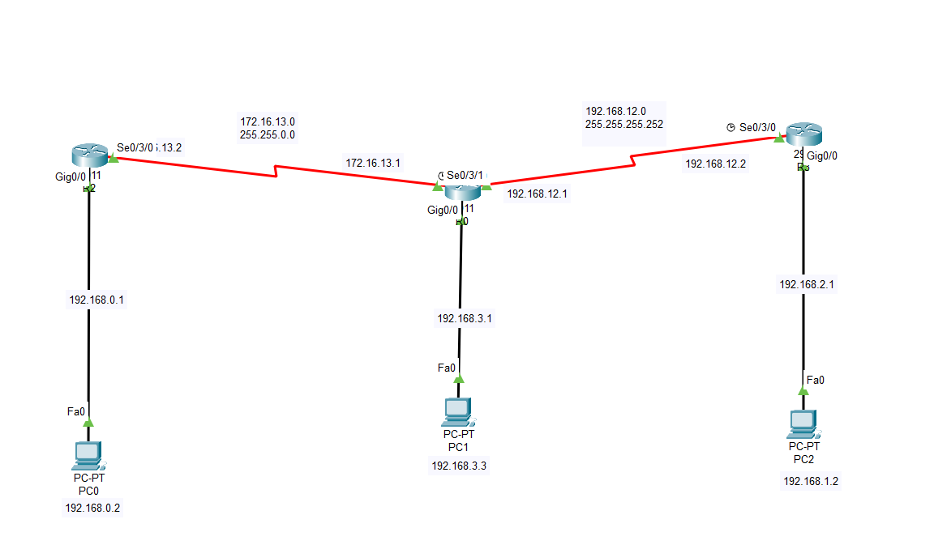

R0 - area 0

router ospf 10

network 172.16.13.0 0.0.0.255 area 0

network 192.168.12.0 0.0.0.3 area 0

network 192.168.3.0 0.0.0.255 area 0

R2 - area 2

router ospf 10

network 172.16.13.0 0.0.0.255 area 0

network 192.168.0.0 0.0.0.255 area 2

R3 - area 3

router ospf 10

network 192.168.12.0 0.0.0.3 area 0

network 192.168.1.0 0.0.0.255 area 3

ping:

tracert 192.168.3.3

NAT/PAT

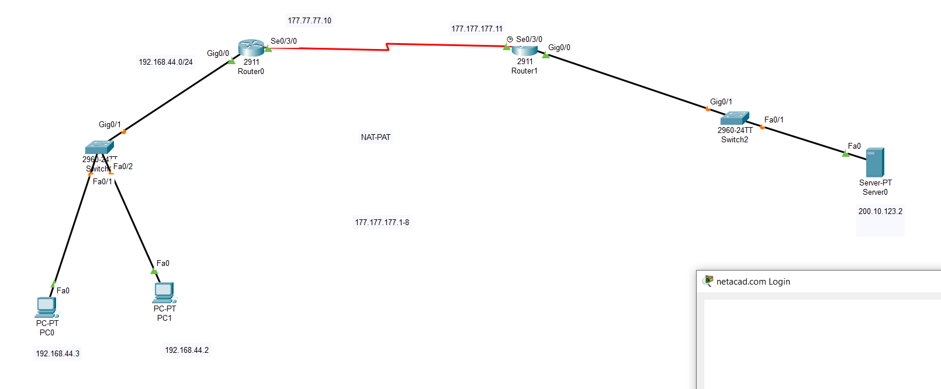

server router

Router(config)#ip route 192.168.44.0 255.255.255.0 177.77.77.10

R0:

R1(config)#ip route 0.0.0.0 0.0.0.0 177.77.77.11

R1(config)#access-list 1 permit 192.168.44.0 0.0.0.255

R1(config)#ip nat pool NAT-POOL 177.77.77.1 177.77.77.7 netmask 255.255.255.0

R1(config)#ip nat inside source list 1 pool NAT-POOL overload

R1(config)#int gig0/0

R1(config-if)#ip nat inside

R1(config-if)#int se0/3/0

R1(config-if)#ip nat outside

Final Assignment

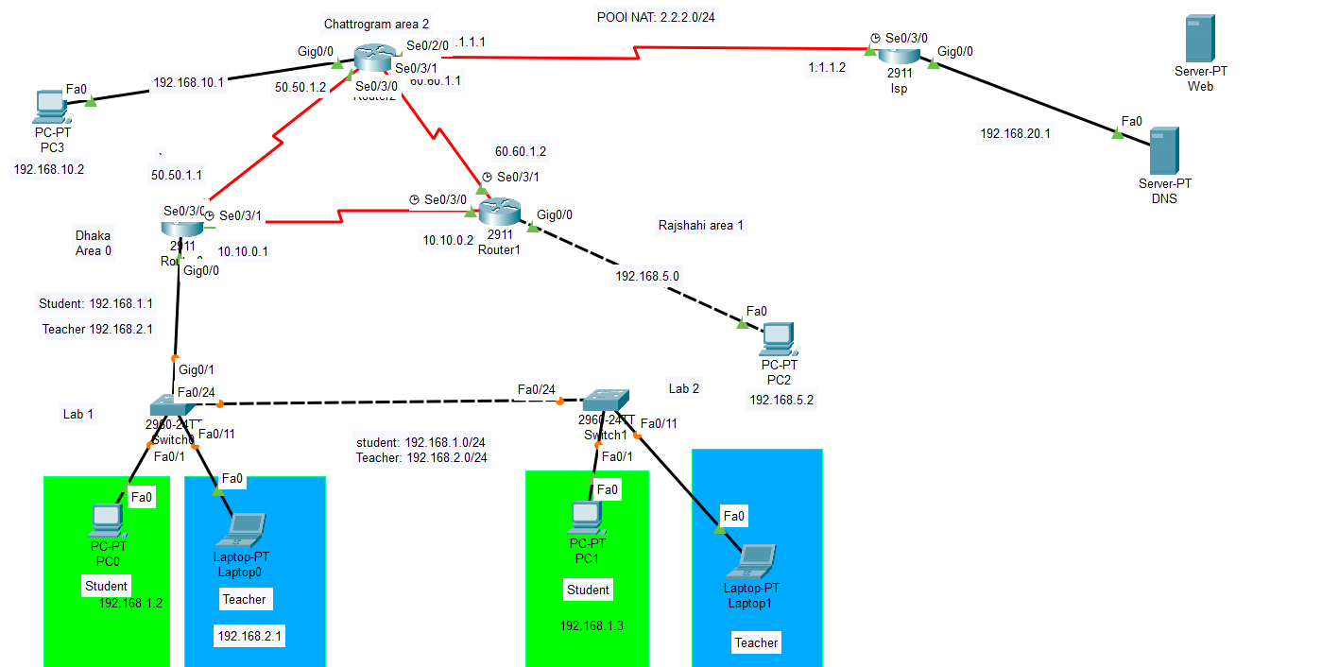

1

DHCP IP:192.168.0.0/24

R1:

----------------------------------------- not working DHCP

ip dhcp excluded-address 192.168.50.254

ip dhcp pool SEU_DHCP

network 192.168.50.0 255.255.255.0

default-router 192.168.50.1

dns-server 192.168.50.254

int gig0/0

ip add 192.168.50.1 255.255.255.0

no shut

----------------------------------------------------------------------------------

sh running-config

vlan:

Switch 1 and Switch 2 in R1

==========================

vlan 2

name STUDENT

vlan 3

name TEACHER

int range fa0/1-9

switchport access vlan 2

switchport mode access

int range fa0/10-20

switchport access vlan 3

switchport mode access

*this stablish a Trunk ...

int fa 0/24

switchport mode trunk

**only switch 2

int gig 0/1

switchport mode trunk

show vlan brief

sh interfaces trunk

inter-vlan:

==========

**R1 Router for config

interface gig0/0.2

encapsulation dot1Q 2

ip add 192.168.1.1 255.255.255.0

**Student

ip dhcp pool Arif

network 192.168.1.0 255.255.255.0

default-router 192.168.1.1

dns-server 8.8.8.8

exit

interface gig0/0.3

encapsulation dot1Q 3

ip add 192.168.2.1 255.255.255.0

**teacher

ip dhcp pool Mesba

network 192.168.2.0 255.255.255.0

default-router 192.168.2.1

dns-server 8.8.8.8

exit

ospf

-------------------------------------------------------

**do sh ip protocols

R0 - area 0

router ospf 10

network 192.168.1.0 0.0.0.255 area 0

network 192.168.2.0 0.0.0.255 area 0

network 10.10.0.0 0.0.0.15 area 0

network 50.50.1.0 0.0.0.255 area 0

R1 - area 1

network 10.10.0.0 0.0.0.15 area 0

network 192.168.5.0 0.0.0.255 area 1

network 60.60.1.0 0.0.0.255 area 2

Nat - area 2

network 192.168.10.0 0.0.0.255 area 2

network 50.50.1.0 0.0.0.255 area 0

network 60.60.1.0 0.0.0.255 area 2

ping:

tracert 192.168.5.2

------------------------------------------------

NAT/PAT

ip route 0.0.0.0 0.0.0.0 1.1.1.2

access-list 1 permit 50.50.0.0 0.0.0.255

access-list 1 permit 192.168.10.0 0.0.0.255

access-list 1 permit 60.60.1.0 0.0.0.255

ip nat pool NAT-POOL 2.2.2.1 2.2.2.5 netmask 255.255.255.0

ip nat inside source list 1 pool NAT-POOL ? // this is pat

overload Overload an address translation

ip nat inside source list 1 pool NAT-POOL overload

int se0/2/0

ip nat outside

int se0/3/1

ip nat inside

ip route 192.168.20.0 255.255.255.0 1.1.1.2

router 1 which connect server:

ip route 50.50.1.0 255.255.255.0 1.1.1.1

ip route 192.168.10.0 255.255.255.0 1.1.1.1

ip route 60.60.1.0 255.255.255.0 1.1.1.1

============================================================

<!DOCTYPE html>

<html>

<head>

<title>My</title>

</head>

<body>

<h2>Md Abdul Wahab Sarker</h2>

<p>BSc in CSE</p>

<p>Souteast University</p>

</body>

</html>

================================= R2

interface GigabitEthernet0/0

ip address 192.168.10.1 255.255.255.0

no shutdown

interface Serial0/3/0

ip address 50.50.1.2 255.255.255.0

no shutdown

interface Serial0/3/1

ip address 60.60.1.1 255.255.255.0

no shutdown

router ospf 10

network 192.168.10.0 0.0.0.255 area 2

network 50.50.1.0 0.0.0.255 area 0

network 60.60.1.0 0.0.0.255 area 2

ex

interface Serial0/2/0

ip address 1.1.1.1 255.255.255.0

no shutdown

================================= R3

interface Serial0/3/0

ip address 1.1.1.2 255.255.255.0

no shutdown